Table of Contents

Abstract ...................................................................................................................... 4
Acknowledgment ....................................................................................................... 5
CHAPTER 1 .............................................................................................................. 6
1.1 Introduction ...................................................................................................... 6
1.2 Background ....................................................................................................... 6
1.3 Motivation ........................................................................................................ 6
1.4 Problem Description ......................................................................................... 7
1.5 Objectives ......................................................................................................... 7
1.6 Methodology ..................................................................................................... 7
1.6.1 Hardware Integration ............................................................................. 7
1.6.2 Software Development .......................................................................... 8
1.6.3 Testing and Optimization ...................................................................... 8
1.7 Limitations ........................................................................................................ 8
1.8 Summary ........................................................................................................... 8
CHAPTER 2 .............................................................................................................. 9
2.1 Technology and Literature Survey ................................................................... 9
2.2 Basic Operations ............................................................................................... 9
2.2.1 Security and Access Control ...................................................................... 9
2.2.5 Remote Monitoring and IoT Control ......................................................... 9
2.5 Required Hardware ........................................................................................... 10
2.6 Required Software ..........................................................................................16
CHAPTER 3
3.1 Hardware connection ......................................................................................17
3.2 Circuit Diagram ............................................................................19
3.3 Functionality of the Project ............................................................................19
3.4 Future Work ....................................................................................................21
CHAPTER 4 ............................................................................................................22
4.1 Cost Estimation...............................................................................................22
4.2 Challenge faced ..............................................................................................22
4.4 Conclusion ......................................................................................................23
4.5 Picture of Smart Home Automation Project (IoT Dwelling) ...................................................24
4.6 Appendices ......................................................................................................25
References: ...............................................................................................................31

Abstract
IoT Dwelling presents a Smart Home Automation and Security System designed using a
microcontroller-based embedded platform. The system is divided into two main parts.
The first part focuses on home automation, including an automatic door lock system and
a Bluetooth-controlled lighting system with voice control functionality. Users can control
home lighting using a smartphone application through Bluetooth communication.

The second part of the project emphasizes home security. A PIR motion sensor is used to
detect unauthorized movement when the user is not at home. Upon motion detection, the
system automatically activates an alarm and turns on lighting to alert nearby people and
deter intruders. The system operates using a mobile hotspot, ensuring functionality even
without a fixed Wi-Fi connection.

The proposed system is low-cost, reliable, and suitable for small residential applications.
It enhances safety, convenience, and security while minimizing human effort.

Acknowledgment
I would like to sincerely thank my supervisors, Md. Omaer Faruq Goni and Oishi Jyoti, Assistant Professors in the Department of Electrical and Computer Engineering, for their invaluable advice, support, and encouragement throughout the project's development. Their knowledge and experience have been crucial in determining the direction of this research, and I am incredibly grateful for their perseverance and commitment, which have been crucial to the successful completion of this work.
I am deeply indebted to the faculty members of the Department of Electrical and Computer Engineering for providing me with the foundational knowledge and technical skills that enabled me to undertake this project. Their dedication to teaching and mentorship has shaped my understanding of the field and inspired me to pursue research with rigor and curiosity.
I would also like to express my appreciation to my fellow students and colleagues who contributed to this journey through meaningful discussions, collaborative problem-solving, and mutual encouragement. Their perspectives and insights enriched my work and made the challenges more manageable.
Finally, I wish to acknowledge the institutional support provided by the university, including access to laboratory facilities, resources, and technical assistance, all of which were essential to the execution of this project.

Osman Goni
On behalf of ‘Team FutureHome’

CHAPTER 1

1.1 Introduction

Home automation and security systems have become increasingly important with the

advancement of embedded systems and wireless communication technologies. Traditional

home systems require manual operation and lack real-time security features. This project

aims to develop a simple and affordable smart home system that provides automation and

security using Bluetooth communication and motion detection.

The proposed system includes an automatic door locking mechanism, Bluetooth-based

light control with voice command support, and a motion-detection-based security system.

When the user is away from home, the system detects motion and activates an alarm and

lighting system to alert and prevent unauthorized access. A mobile hotspot is used for

communication, making the system independent of fixed internet infrastructure.

1.2 Background
Traditional home systems require manual control, making them inefficient and prone to security vulnerabilities. With the emergence of smart home technology, automation enables energyefficient and secure home management. This project integrates IoT-based automation, real-time monitoring, and security enhancements to create a smart home solution that minimizes human intervention and maximizes convenience.

1.3 Motivation
The increasing demand for smart home systems is driven by concerns about security, energy efficiency, and convenience. Issues such as unauthorized access, high energy consumption, and lack of remote control capabilities highlight the need for an automated solution. This project aims to develop a system that provides intelligent control over home appliances while ensuring security and user accessibility.

1.4 Problem Description
Despite the availability of automation solutions, existing home systems face challenges such as:
- Security risks – Traditional locks and manual security measures are prone to breaches.
- Energy inefficiency – Lights and appliances are often left on unnecessarily, increasing electricity bills.
- Manual operation – Home devices require direct physical interaction for control.
This project seeks to address these issues by integrating IoT-based control, smart authentication,

1.5 Objectives
The key objectives of this research are:
- Develop an IoT-based smart home system using Arduino Uno and ESP 32.
- Integrate automation mechanisms for lights, fans, and appliances using relay modules.
- To design an automatic door locking system using a servo motor.
- To implement Bluetooth-based light control with voice command functionality.
- To develop a motion detection security system using a PIR sensor.
- To ensure system operation using a mobile hotspot without relying on fixed Wi-Fi.

1.6 Methodology
The project follows a structured approach:

1.6.1 Hardware Integration
- Microcontrollers: Arduino Uno , ESP 32.
- Sensors:, ultrasonic, PIR,
- Actuators: Servo motors, relay modules, buzzers.
- Communication: hotspot for IoT connectivity

1.6.2 Software Development
- Programming: Arduino IDE for firmware development.
- Automation Logic: Implement sensor-based automated responses.

1.6.3 Testing and Optimization
- Test various home scenarios to ensure seamless automation.
- Optimize power consumption for efficient energy management.

1.7 Limitations
Despite its benefits, the proposed system has some limitations:
- Hotspot dependency – Remote control features require a stable mobile hotspot connection.
- Environmental interference – PIR sensor may be affected by external conditions.
- Power constraints – Multiple sensors and actuators require efficient power management.
- Unauthorized Access – Automatic door on/off system without authorizing the individual.

1.8 Summary
This project presents an IoT-enabled smart home automation system that integrates security, automation, and remote monitoring. Using Arduino Uno and ESP 32, the system enhances home security, optimizes energy consumption through automated lighting and fan control, and improves safety. While the system has some limitations, its ability to automate daily tasks, enhance security, and provide real-time monitoring makes it a practical and cost-effective solution for modern homes.

CHAPTER 2

2.1 Technology and Literature Survey
Smart home automation has evolved with advancements in IoT, artificial intelligence, and embedded systems, leading to efficient and intelligent solutions for home management. Research in smart home technology primarily focuses on security, energy efficiency, and automation. Studies highlight the integration of motion detection mechanisms to enhance home security and convenience. Existing systems, such as Google Nest and Amazon Alexa, demonstrate the potential of AI-driven smart home environments, but they rely heavily on cloud-based processing. Several research papers discuss the application of Arduino and ESP microcontrollers for cost-effective automation, enabling real-time monitoring via IoT platforms. Comparative studies indicate that relay-based control of appliances, coupled with sensor-driven automation, improves efficiency while reducing energy consumption. However, challenges such as connectivity issues, power management, and authentication security remain significant. This project builds upon previous research by integrating sensor-driven automation, ensuring a robust and scalable smart home solution.

2.2 Basic Operations

2.2.1 Motion-Based Security System
A PIR motion sensor detects movement when the user is not at home. If motion is detected,
the system activates an alarm and turns on lighting automatically to alert nearby people
and discourage intruders.

2.2.2 Energy Management
- Automatic Lighting: PIR sensors turn lights on/off based on brightness and movement.
- Relay-based Appliance Control: Manages electrical devices remotely using IoT.

2.2.3 Automatic Door Lock System
. The automatic door lock system uses a servo motor controlled by a microcontroller.
The door locks or unlocks based on predefined control logic, eliminating the need for
manual locking and improving safety.

2.2.5 Remote Monitoring and IoT Control
- Application Platforms: Allows users to monitor and control appliances via smartphones.
- ESP Modules: Enables cloud-based automation and alerts.

2.2.6 Bluetooth Light Control with Voice Command
A Bluetooth module enables wireless communication between the smartphone and
microcontroller. Users can turn lights ON or OFF using a mobile application with voice
command support, providing convenience and hands-free operation.

2.5 Required Hardware
- Arduino Uno : The Arduino Uno R3 is a microcontroller board based on the
ATmega328P, widely used for electronics and embedded systems projects. It features 14 digital I/O pins (6 supporting PWM), 6 analog inputs, and supports UART, I2C, and SPI communication. Powered by 5V USB or 7-12V external supply, it has 32KB flash memory, 2KB SRAM, and 1KB EEPROM for data storage. The board is programmed using the Arduino IDE via a USB Type-B connection. With its built-in LED on pin 13, it is ideal for prototyping, sensor interfacing, robotics, and IoT applications.

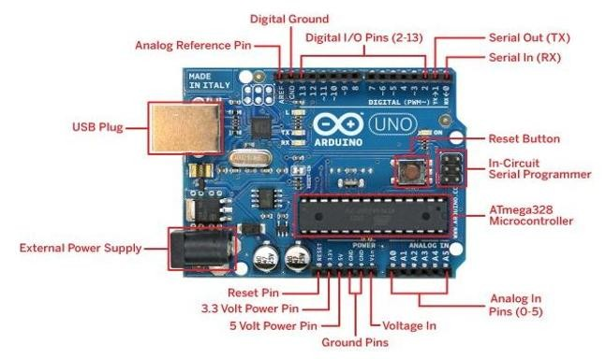
Figure: Arduino Uno R3

- ESP C3 Mini: The ESP-C3 Mini is a compact and efficient Wi-Fi and Bluetooth Low Energy (BLE) module based on the ESP32-C3 chip, designed for IoT applications. It features a RISC-V 32-bit single-core processor, operating at up to 160 MHz, with built-in 2.4 GHz Wi-Fi and Bluetooth 5.0 (LE) for wireless connectivity. The module supports multiple GPIOs, SPI, I2C, UART, ADC, and PWM interfaces, making it versatile for embedded applications. It has low power consumption with deep sleep modes, making it ideal for battery-powered devices. The ESP-C3 Mini is commonly used in smart home devices, wearables, and industrial automation due to its compact size, security features, and strong wireless capabilities.
The ESP-C3 Mini supports secure boot, flash encryption, and WPA3 for enhanced security. It integrates 4 MB flash memory, making it suitable for firmware storage. With low-power modes, it extends battery life, making it ideal for IoT, automation, and smart devices applications.
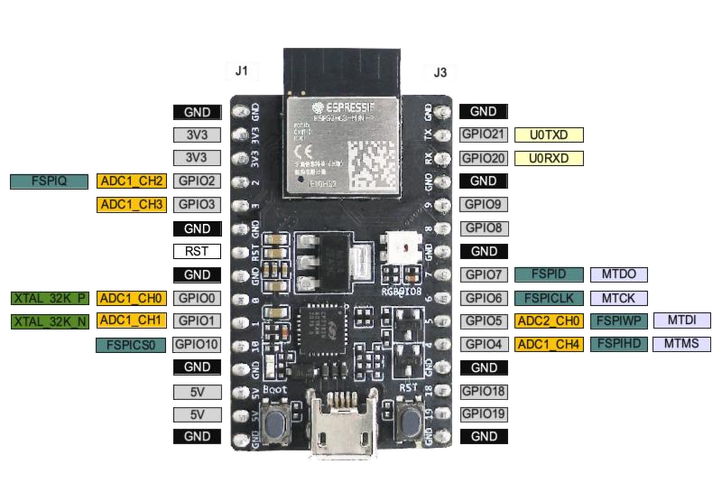
Figure: ESP-C3 Mini

- Ultrasonic Sensor (HC-SR04): The HC-SR04 ultrasonic sensor is used for measuring distances by emitting ultrasonic waves and calculating the time it takes for the waves to bounce back after hitting an object. It consists of two main components: a transmitter that sends out a high-frequency sound pulse and a receiver that detects the echo. The sensor calculates the distance by measuring the time between the transmission and reception of the sound wave, using the formula: distance = (time * speed of sound) / 2. This sensor is commonly used in robotics, obstacle detection, and proximity sensing applications.
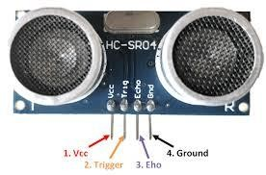
Figure: Ultrasonic Sensor (HC-SR04)

- PIR Motion Sensor: A PIR (Passive Infrared) motion sensor detects motion by measuring changes in infrared radiation emitted by objects, typically human bodies. It consists of a sensor that detects heat variations in its surroundings. When a warm object moves within its range, the sensor triggers an output, commonly used in security systems, automatic lighting, and motion-triggered alarms.
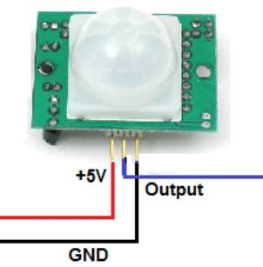
Figure: PIR Motion Sensor

- Servo Motor (SG90 ): Two servo motors are used to control the pan-tilt mechanism. The SG90 servo, a lightweight option with 180° rotation, operates on 4.8V–6V, while the MG995 is a more powerful alternative with a torque rating of 13kg/cm. These servos, controlled by PWM signals from the ESP32, allow precise adjustments to the camera’s viewing angle.

Figure: Pin Diagram of Servo Motor (SG90)

- 4-Channel Relay Module: A 4-channel relay module is used to control multiple highvoltage devices like motors, lamps, and home appliances through low-voltage circuits. It consists of four independent relays, each with a switch that can be activated by a microcontroller or other digital control sources, like Arduino. When a control signal is applied to a relay, it switches from its default state (either open or closed) to allow or block the flow of electricity. The module typically supports both normally open (NO) and normally closed (NC) configurations, providing flexibility in controlling external devices safely.
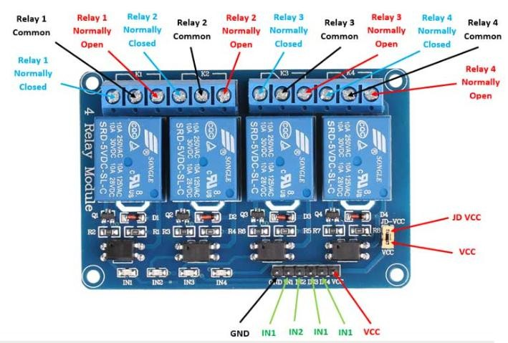
Figure: 4 Channel Relay Module
- Buzzer: A buzzer is an electronic device that produces sound when activated. It operates using piezoelectric or electromagnetic principles, commonly used in alarms, timers, and notifications for alerts or warnings in various systems.
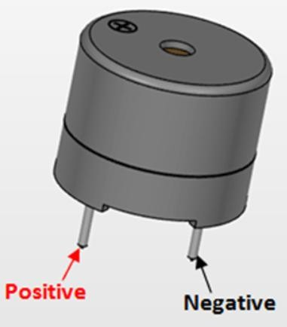
Figure: Pin Diagram of Buzzer

- Jumper Wires: Jumper wires connect various electronic components, enabling signal and power transmission. These include male-to-male, male-to-female, and female-tofemale configurations, supporting low-current connections up to 2A. They play a crucial role in establishing reliable links between the microcontroller, sensors, and actuators.

- Bluetooth Module: The HC-05 is a widely-used Bluetooth 2.0 module that enables wireless serial communication between devices, commonly found in Arduino and microcontroller projects. Operating at 3.3V-6V with a range of about 10 meters, it can function in both master and slave modes and communicates via simple TX/RX serial pins. The module is popular for its ease of use, affordability, and versatility in applications like robotics, home automation, and wireless sensor networks. It can be configured using AT commands to adjust settings like baud rate (default 9600 bps), device name, and pairing PIN, making it an excellent choice for hobbyists and developers looking to add Bluetooth connectivity to their projects without complex programming.

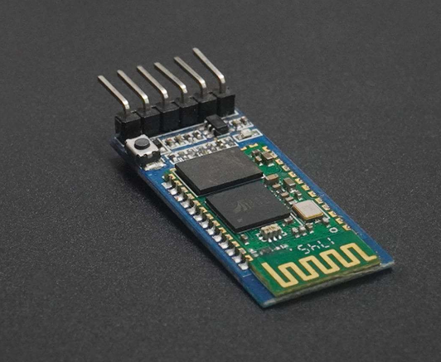
Figure: HC-05 Bluetooth Module

2.6 Required Software
1. Arduino IDE: The Arduino IDE (Integrated Development Environment) is the official software platform used to write, compile, and upload code to Arduino microcontroller boards. It features a simplified C/C++ programming environment with a user-friendly interface that makes embedded programming accessible to beginners while remaining powerful enough for advanced users. The IDE includes a code editor with syntax highlighting, a built-in library manager for adding functionality, a serial monitor for debugging and communication, and support for a wide range of Arduino boards and compatible microcontrollers. It uses a simplified programming structure based on two main functions—setup() for initialization and loop() for continuous execution—and comes with numerous example sketches to help users get started quickly. Available for Windows, macOS, and Linux, the Arduino IDE has become the standard tool for prototyping electronics projects, making it easy to transform code into working hardware applications with just a USB connection and a single click to upload.
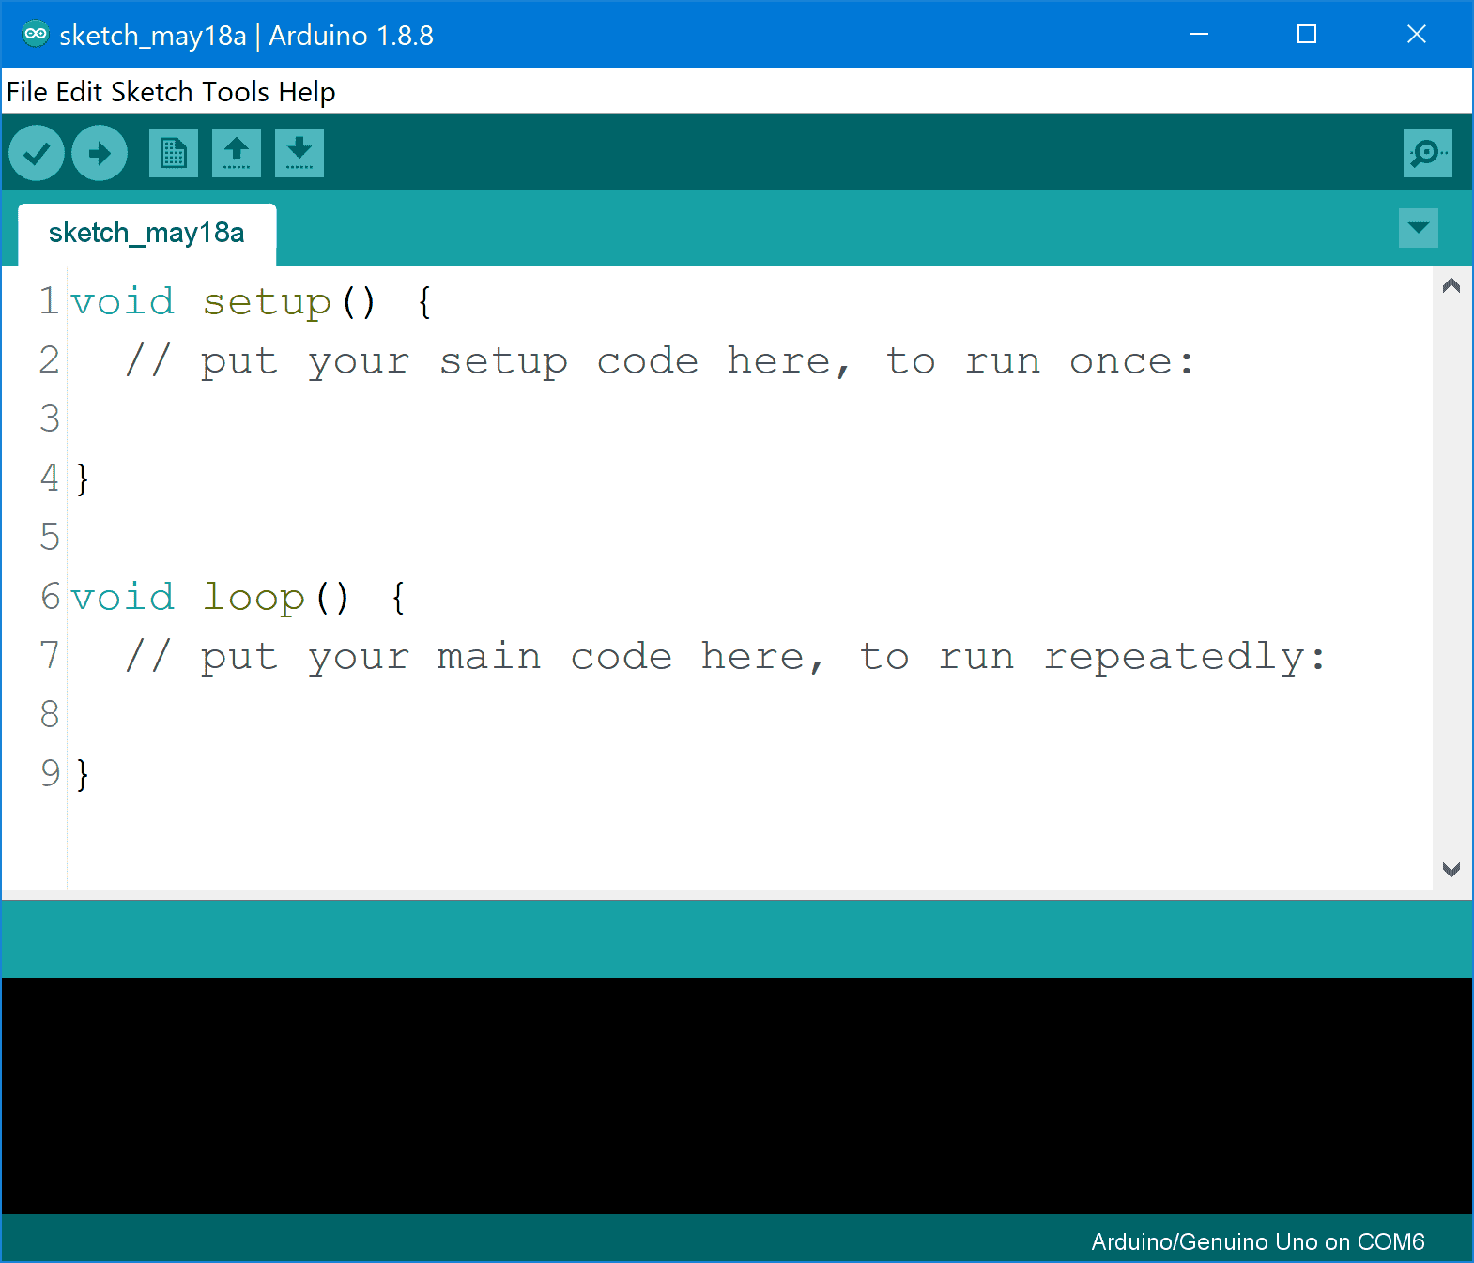
Fig: Arduino IDE

CHAPTER 3

3.1 Hardware connection

- Door Servo Motor Connections:
Component | Arduino Pin
Door Servo (Signal) | 3
Door Servo (VCC) | 5V
Door Servo (GND) | GND

- Ultrasonic Sensor (HC-SR04) Connections:
Ultrasonic Sensor Pin | Arduino Pin
VCC | 5V
GND | GND
TRIG | 11
ECHO | 10

- Thief Alarm (Buzzer) Connections:
Component | Arduino Pin
LED (Vcc) | GPIO 25
LED (GND) | GND

- PIR Motion Sensor Connection:
Component | ESP-32 C3 Pin
PIR (VCC) | 5V
PIR (GND) | GND
PIR (OUT) | GPIO 27

- Buzzer Connection:
Component | ESP-32 C3 Pin
Buzzer (+) | GPIO 26
Buzzer GND | GND

3.2 Circuit Diagram
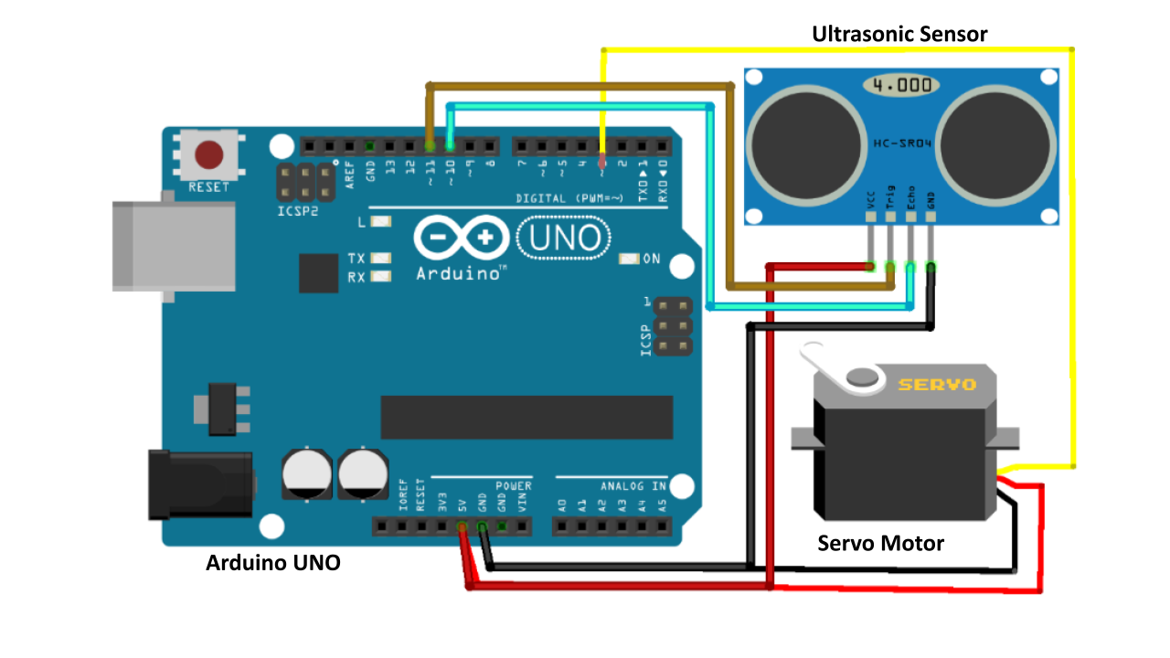
Fig: Circuit Diagram for door automation using Ultrasonic Sensor
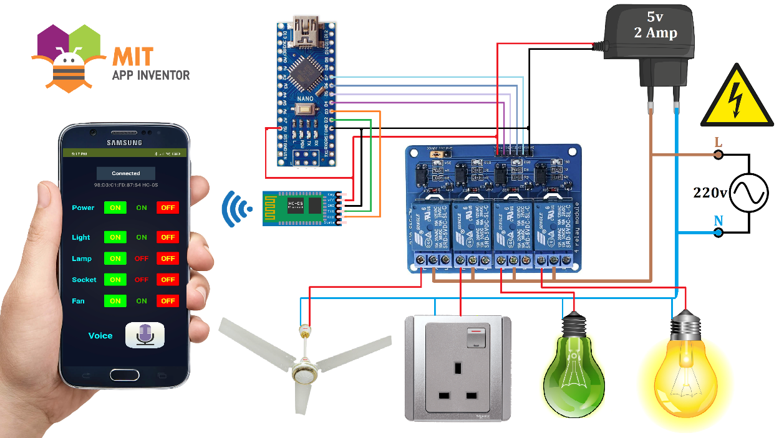
Fig: Circuit Diagram for IoT Based Automation

3.3 Functionality of the Project

Servo Motor (Door Locking): The servo motors are responsible for physically locking or unlocking the door and controlling the opening and closing of the dustbin lid. The first servo motor is connected to the door lock mechanism, where it moves to either lock or unlock the door based
PIR Motion Sensor (Motion Detection & LED Control): The PIR motion sensor detects motion within a predefined area. When motion is detected, the system triggers a response, which, in this case, turns on an LED light. The user can enable or disable the motion detection functionality via the Blynk app. If motion is detected while the feature is active, the system automatically turns on the LED. If no motion is detected, the LED will be turned off, enhancing security and energy efficiency by ensuring lights are only on when needed.
Door Sensor (Intruder Detection & Security): When the user is at home, the system allows Bluetooth-based control of lighting using a
mobile application with voice command support. The automatic door lock system ensures
secure access using a servo motor.

When the user leaves home, the system switches to security mode. The PIR motion sensor
monitors the environment continuously. If motion is detected, the system immediately
activates an alarm and turns on lights. This alerts neighbors and acts as a deterrent to
unauthorized entry.

The system operates using a mobile hotspot, ensuring continuous functionality even in
areas without fixed internet connections.
Buzzer (Alert & Alarm): The buzzer is an essential component for alerting users to potential threats or emergencies. It is activated in situations such as fire detection or intruder detection. When the fire sensor detects fire or smoke, the buzzer emits a loud alarm to alert the user and anyone in the vicinity of the potential danger. Similarly, if the laser sensor detects an intruder, the buzzer is triggered to indicate unauthorized entry. Additionally, the buzzer serves as a feedback mechanism, ensuring that the user is alerted in case of any dangerous situation.
4-Channel Relay (Light Control via Blynk App): The 4-channel relay module in this project is used to control a light connected to a 220V power supply. The relay acts as a switch that allows or interrupts the flow of electricity to the connected light. The relay module receives control signals from the microcontroller (in this case, the ESP C3 Mini) via its GPIO pins, which are controlled through the Blynk app. By toggling the relay through the app, you can turn the light on or off remotely. The relay allows for safe switching of high-voltage devices, such as the light, without directly interacting with the high voltage, as the relay acts as an intermediary switch. When the control pin of the relay is activated, it closes the circuit and powers the light, and when deactivated, it opens the circuit and cuts the power to the light. This integration enables convenient home automation with remote control of lights through the Blynk app, making it easy to manage your home lighting from anywhere.
App (Remote Control & Monitoring): The app serves as the user interface for remote control and monitoring of all the components in the system. It allows the user to adjust the fan speed, control the LED, enable or disable motion detection, and receive real-time alerts for events like fire or intrusion. The app communicates with the ESP32 via hotspot to provide a seamless experience where the user can control the system remotely from anywhere. Notifications for emergencies are also sent directly to the app, ensuring the user is always informed of critical events.

3.4 Future Work
Enhanced Security Features: To further improve security, advanced features like facial recognition, fingerprint scanning, or even the integration of smart cameras could be added. This would provide multi-layered authentication for accessing the home, ensuring that only authorized individuals can enter. The system could also trigger alerts or notifications in case of any unauthorized access attempts, ensuring that the home remains secure.

Energy Efficiency and Power Management: The system can be expanded to monitor and optimize energy consumption by integrating smart plugs and appliances that can be controlled remotely. By analyzing the energy usage patterns of various devices, the system could intelligently manage power consumption—turning off lights, fans, or other devices when not in use. This could reduce overall electricity costs and promote sustainable living.

Mobile App Enhancements: The current Blynk mobile app can be enhanced with additional features such as geofencing, which would automatically trigger certain actions based on the user's location. Other possible upgrades include scheduling for devices, push notifications for system alerts, and more detailed control options for users to interact with their smart home devices from anywhere

Integration with More Smart Appliances: The smart home system could be expanded to include more connected appliances, such as refrigerators, washing machines, and air conditioners. These appliances could be remotely controlled or even operate autonomously based on conditions set by the user. This expansion would make the system more comprehensive, offering increased automation and control over various household functions.

Scalability for Larger Spaces and Multi-Home Use: To accommodate larger homes or multiple residences, the system could be made scalable. More devices, sensors, and relays could be added to support the automation of larger spaces such as offices or commercial buildings. Multi-home support would allow the system to be used in various locations, providing remote control and monitoring of multiple smart homes from a single app.

CHAPTER 4

4.1 Cost Estimation
Here’s the total cost estimation for the Smart Home Automation project:
- Breadboard×3: 400 Tk
- Arduino Uno×2 : 1400 Tk
- Esp32 C3 Mini: 500 Tk
- Battery Casing: 40 Tk
- Sonar Sensor: 100 TK
- HC-05 Bluetooth Module: 350 Tk
- PIR Motion Sensor: 90 Tk
- 4-Channel Relay Module: 270 Tk
- Buzzer & LED Indicators: 100 Tk
- Light and Holder×2: 350 Tk
- Small Motor and Fan: 60 Tk
- Connecting Wires: 300 Tk
- Home Design: 1300 Tk
Total Cost: 5260 Taka.

4.2 Challenge faced
Hardware Compatibility: Ensuring all components (Arduino, ESP32, sensors, etc.) worked together smoothly required careful wiring and pin configuration.
Power Supply: Managing power for multiple components, especially with motors and sensors, needed an external power supply to avoid overloading the Arduino.
Sensor Calibration: Calibration of sensors like LDR, DHT11, and flame sensor for accurate readings required fine-tuning in different conditions.
Wireless Communication: Setting up ESP32 C3 mini for reliable Wi-Fi communication was tricky, but resolved by proper configuration and testing.
Data Handling: Managing sensor data without delays required careful timing and using interrupts for real-time processing.
Relay Control: Using a 4-channel relay to control actuators needed additional components like transistors to handle higher voltage safely.
Motion Detection: Preventing false motion sensor triggers involved adjusting sensitivity and adding time delays for reliability.
Debugging: Troubleshooting the system with multiple components was challenging but handled by isolating issues and using serial monitoring.
User Interface: Designing a simple and intuitive control system was essential, and a userfriendly interface was created for ease of use.
Safety Concerns: Ensuring sensors functioned safely in various environments involved adding checks for false alarms and proper enclosures for protection.

4.4 Conclusion
The Smart Home Automation project successfully integrates various electronic components and sensors to enhance the functionality and convenience of home management. By utilizing the Arduino Uno R3 and ESP32 C3 Mini, we were able to create a system capable of wirelessly controlling devices and gathering real-time data. The Sonar Sensor provide an efficient access control mechanism, ensuring that only authorized individuals can interact with the system. The integration of the Motion Sensor, This project successfully demonstrates a simple and effective smart home automation and
security system. The integration of automatic door locking, Bluetooth voice-controlled
lighting, and motion-based security enhances safety and convenience. The use of a mobile
hotspot ensures flexibility and independence from fixed internet infrastructure. The system
is low-cost, easy to implement, and suitable for residential applications.

4.5 Picture of Smart Home Automation Project (IoT Dwelling)

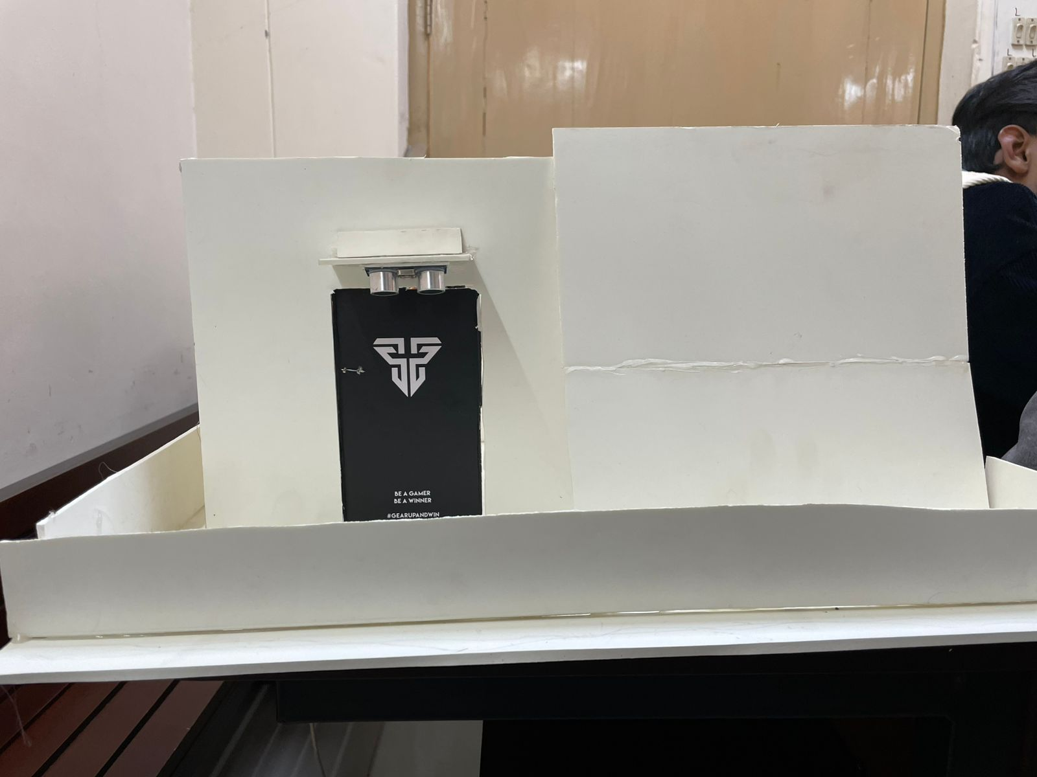
Figure: Front View
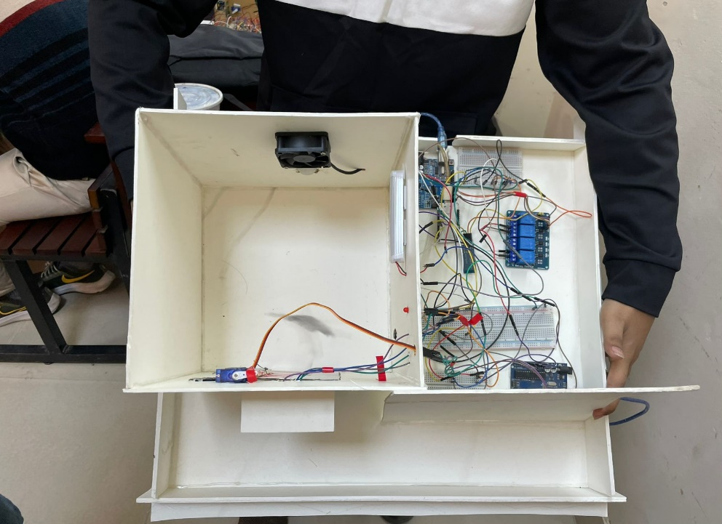
Figure: Top View
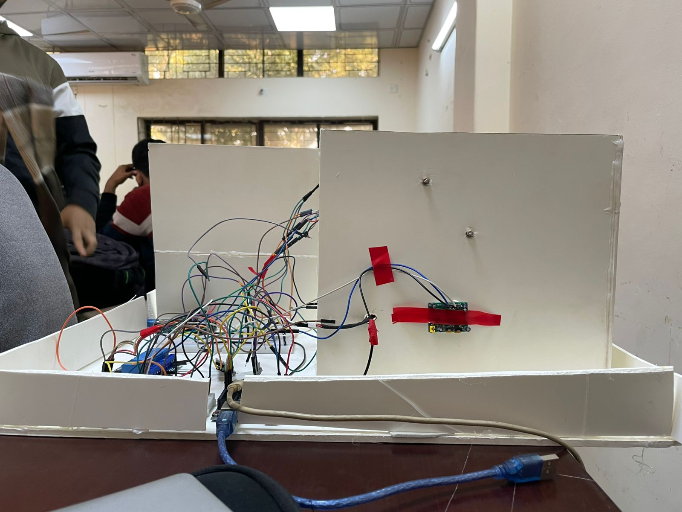
Figure: Back View

4.6 Appendices

Arduino Code (For Home Automation):
#include <EEPROM.h>
#include <SoftwareSerial.h>
SoftwareSerial BT_Serial(2, 3);

#define Relay1 4 // Load1 Pin Out
#define Relay2 5 // Load2 Pin Out
#define Relay3 6 // Load3 Pin Out
#define Relay4 7 // Load4 Pin Out

char bt_data; // variable to receive data from the serial port
int load1, load2, load3, load4, power;

void setup(){
Serial.begin(9600);
BT_Serial.begin(9600);

pinMode(Relay1, OUTPUT); digitalWrite(Relay1, 1);
pinMode(Relay2, OUTPUT); digitalWrite(Relay2, 1);
pinMode(Relay3, OUTPUT); digitalWrite(Relay3, 1);
pinMode(Relay4, OUTPUT); digitalWrite(Relay4, 1);

load1 = EEPROM.read(1);
load2 = EEPROM.read(2);
load3 = EEPROM.read(3);
load4 = EEPROM.read(4);

power = EEPROM.read(5);
delay(500);
}

void loop() {
if(BT_Serial.available()>0){bt_data = BT_Serial.read();}

if(bt_data == 'A'){load1=0;EEPROM.write(1, load1);}
if(bt_data == 'a'){load1=1;EEPROM.write(1, load1);}

if(bt_data == 'B'){load2=0;EEPROM.write(2, load2);}
if(bt_data == 'b'){load2=1;EEPROM.write(2, load2);}

if(bt_data == 'C'){load3=0;EEPROM.write(3, load3);}
if(bt_data == 'c'){load3=1;EEPROM.write(3, load3);}

if(bt_data == 'D'){load4=0;EEPROM.write(4, load4);}
if(bt_data == 'd'){load4=1;EEPROM.write(4, load4);}

if(bt_data == 'E'){power=0;EEPROM.write(5, power);}
if(bt_data == 'e'){power=1;EEPROM.write(5, power);}

bt_data = '0';

if(power==1){
digitalWrite(Relay1, 1);
digitalWrite(Relay2, 1);
digitalWrite(Relay3, 1);
digitalWrite(Relay4, 1);
}else{
digitalWrite(Relay1, load1);
digitalWrite(Relay2, load2);
digitalWrite(Relay3, load3);
digitalWrite(Relay4, load4);
}

BT_Serial.print(power);
BT_Serial.print(";");
BT_Serial.print(load1);
BT_Serial.print(";");
BT_Serial.print(load2);
BT_Serial.print(";");
BT_Serial.print(load3);
BT_Serial.print(";");
BT_Serial.print(load4);
BT_Serial.println(";");

delay(500);
}

Arduino Code (Door Control):
#include <Servo.h>

#define TRIG_PIN 11
#define ECHO_PIN 10
#define SERVO_PIN 3

Servo doorServo;
int currentAngle = 0;

void setup() {
pinMode(TRIG_PIN, OUTPUT);
pinMode(ECHO_PIN, INPUT);
doorServo.attach(SERVO_PIN);
doorServo.write(currentAngle);
Serial.begin(9600);
}

long getDistance() {
digitalWrite(TRIG_PIN, LOW);
delayMicroseconds(2);
digitalWrite(TRIG_PIN, HIGH);
delayMicroseconds(10);
digitalWrite(TRIG_PIN, LOW);

long duration = pulseIn(ECHO_PIN, HIGH);
long distance = duration * 0.034 / 2; // Convert time to distance (cm)
return distance;
}

void smoothServoMove(int targetAngle) {
if (targetAngle > currentAngle) {
for (int angle = currentAngle; angle <= targetAngle; angle++) {
doorServo.write(angle);
delay(10);
}
} else {
for (int angle = currentAngle; angle >= targetAngle; angle--) {
doorServo.write(angle);
delay(10);
}
}
currentAngle = targetAngle;
}

void loop() {
long distance = getDistance();
Serial.print("Distance: ");
Serial.print(distance);
Serial.println(" cm");

if (distance > 0 && distance <= 3) { // If object detected within 3 cm
smoothServoMove(90);
delay(3000);
} else {
smoothServoMove(0);
}
delay(500);
}
ESP32 Code (For Security System):
#include <WiFi.h>

const char* hotspotSSID = "Niloy";
const char* hotspotPassword = "aaaaaaaa";

const int pirPin = 27;
const int ledPin = 25;
const int buzzerPin = 26;

bool wifiConnected = false;
unsigned long lastWifiCheck = 0;

void setup() {
Serial.begin(115200);

pinMode(pirPin, INPUT_PULLUP);
pinMode(ledPin, OUTPUT);
pinMode(buzzerPin, OUTPUT);

digitalWrite(ledPin, LOW);
digitalWrite(buzzerPin, LOW);

delay(20000); // PIR warm-up

Serial.println("WiFi Security System Ready");
Serial.println("Connected to hotspot = ARMED (safe)");
Serial.println("Disconnected = DISARMED (ALARM triggers)");
printStatus();

WiFi.begin(hotspotSSID, hotspotPassword);
Serial.printf("Connecting to hotspot: %s\n", hotspotSSID);
}

void loop() {
if (millis() - lastWifiCheck > 5000) {
wifiConnected = (WiFi.status() == WL_CONNECTED);
if (wifiConnected != lastWifiCheck / 5000) {
printStatus();
}
lastWifiCheck = millis();
}

// ALARM only when WiFi DISCONNECTED (DISARMED)
if (!wifiConnected && digitalRead(pirPin) == HIGH) {
digitalWrite(ledPin, HIGH);
digitalWrite(buzzerPin, HIGH);
Serial.println("*** INTRUDER ALERT! WiFi OFF - MOTION DETECTED ***");
delay(1000);
digitalWrite(ledPin, LOW);
digitalWrite(buzzerPin, LOW);
}
}

void printStatus() {
if (wifiConnected) {
Serial.println("ARMED: Connected to hotspot ✓ (Motion ignored)");
} else {
Serial.println("DISARMED: No WiFi connection ✗ (ALARM ACTIVE)");
}
Serial.println("---");
}

References:
  - A. Al-Fuqaha, M. Guizani, M. Mohammadi, M. Ayyash, S. S. He, and M. A. E. Hossain, "Internet of Things: A Survey on Enabling Technologies, Protocols, and Applications," IEEE Communications Surveys & Tutorials, vol. 17, no. 4, pp. 2347-2376, 4th Quart., 2015.
  - M. A. Khan, A. K. M. Z. Haider, and A. S. M. H. Gazi, "Smart Home Automation System Using Arduino and ESP32," 2018 2nd International Conference on Computing, Mathematics and Engineering Technologies (iCoMET), Sukkur, Pakistan, 2018, pp. 1-5.
  - M. A. Hossain, M. A. R. Mamun, M. R. Khan, and M. S. Islam, "Design and Implementation of Smart Home Automation System Using Arduino," 2016 International Conference on Robotics, Automation, Control and Embedded Systems (RACE), Dhaka, Bangladesh, 2016, pp. 68-72.
  - S. A. B. S. S. S. A. A. Younis, "Home Automation with IoT," 2016 5th International Conference on Electrical Engineering (ICEE), Karachi, Pakistan, 2016, pp. 295-299.
  - M. A. K. A. A. S. S. V. Krishnan, "Design and Implementation of Arduino Based Home Automation System with Smart Access Control Using RFID," 2015 IEEE International Conference on Computational Intelligence and Computing Research, Chennai, India, 2015, pp. 1-4.
  - V. S. Nagarajan, K. R. S. S. Y. Chaitanya, and M. S. M. R. S. K. Reddy, "Arduino Based Home Automation System," 2014 IEEE International Conference on Control and Computing (ICCC), Pune, India, 2014, pp. 150-154.
  - P. Sharma, R. R. Tiwari, and R. K. Sharma, "Internet of Things Based Home
Automation with Smart Security System," 2017 IEEE International Conference on Computing, Communication and Automation (ICCCA), Greater Noida, India, 2017, pp. 964-968.
  - P. R. Pradhan, B. K. Sahu, and S. K. Sahu, "Arduino Based Home Automation System Using IoT," 2017 2nd International Conference on Communication and Electronics Systems (ICCES), Coimbatore, India, 2017, pp. 1-5.
  - R. G. Rojas, A. G. Santana, and A. G. Perez, "IoT Based Smart Home Automation Using Arduino," 2016 6th International Conference on Information Technology and Electrical Engineering (ICITEE), Yogyakarta, Indonesia, 2016, pp. 1-4.
  - S. R. S. A. S. M. M. J. E. C. Young, "Home Automation Using Arduino and Smart Devices," 2019 International Conference on Computing and Network Communications (CoCoNet), Chennai, India, 2019, pp. 213-217.
  - C. P. Y. G. G. Kumar, "Design and Implementation of Arduino-based Home Automation System with Wireless Control," 2014 IEEE International Conference on Communication and Signal Processing, Melmaruvathur, India, 2014, pp. 758-762.
  - A. T. S. G. K. G. Ali, "Smart Home Automation Using Arduino and IoT," 2019 International Conference on Electronics and Communication Systems (ICECS), Coimbatore, India, 2019, pp. 228-233.
  - G. T. R. G. A. R. M. R. P. Kumar, "Smart Home Automation Using Arduino and Internet of Things (IoT) Based Technologies," 2017 IEEE 8th International Conference on Computing, Communication and Networking Technologies (ICCCNT), Bangalore, India, 2017, pp. 1-6.
  - S. S. A. K. S. M. V. Kumar, "Design and Development of Smart Home System using Arduino," 2015 IEEE International Conference on Computing Communication and Networking Technologies (ICCCNT), Coimbatore, India, 2015, pp. 1-6.
  - S. B. M. A. G. R. Y. A. K. G. T. B. S. Shah, "Design and Implementation of a Smart Home Automation System Using Arduino and IoT," 2018 International Conference on Communication and Signal Processing (ICCSP), Chennai, India, 2018, pp. 2116-2120.
  - S. Kumar, S. K. Agarwal, and M. K. Srivastava, "IoT-Based Smart Home Automation Using Arduino and ESP32," 2019 International Conference on Signal Processing and Communication (ICSC), Kochi, India, 2019, pp. 104-109.
  - M. G. A. S. Kumar, and P. G. M. Singh, "Design of Smart Home Automation System Using Sensors and Arduino," 2017 IEEE 2nd International Conference on Electronics, Communication and Aerospace Technology (ICECA), Coimbatore, India, 2017, pp. 303-307.
  - M. B. N. D. M. A. B. S. A. F. B. S. G. K. R. Y. Y. Jain, "Smart Home Automation System Using Arduino and IoT," 2018 IEEE International Conference on Research in Intelligent and Computing in Engineering (RICE), Coimbatore, India, 2018, pp. 87-92.
  - A. B. S. S. A. R. B. Patel, "Smart Home Automation with IoT Using Arduino," 2017 IEEE International Conference on Smart Technologies and Management for Computing, Communication, Controls, Energy and Materials (ICSTM), Coimbatore, India, 2017, pp. 102-107.

